**Operating System Lab**

**Lab Report : 03**



**Spring 2019**

**Operating System**

Submitted By : **Naveed Ahmad**

Registration No : **17PWCSE1507**

Class Section: **B**

“On my honor, as student of University of Engineering and Technology, I have neither given nor received unauthorized assistance on this academic work.”

Submitted to:

**Dr. Tariq Kamal**

March 5, 2019

**Department of Computer Systems Engineering**

**University of Engineering and Technology, Peshawar**

**Lab Report : 03**

**Basic Shell Scripting**

**Objective:**

To know and get Familiar with Shell Scripting in Ubuntu.

## Lab Tasks

**Task : 01**

**Write a bash script that removes all the blank lines from file1.txt.**

**Shell Script :**

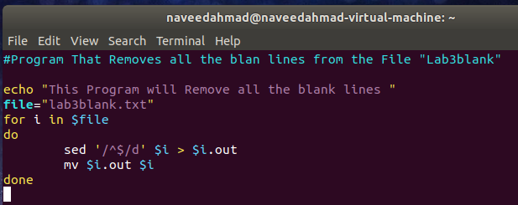

**Output :**

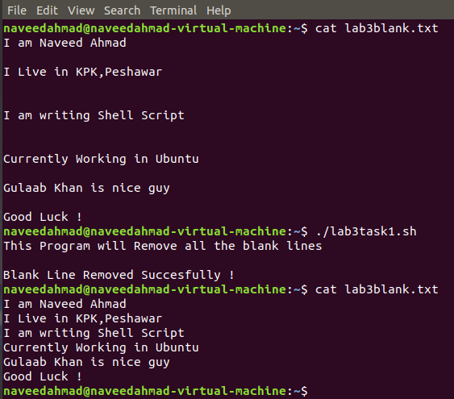

**Task : 02**

**Write a script that determines if an argument passed to it is an integer or a string.**

**Shell Script :**

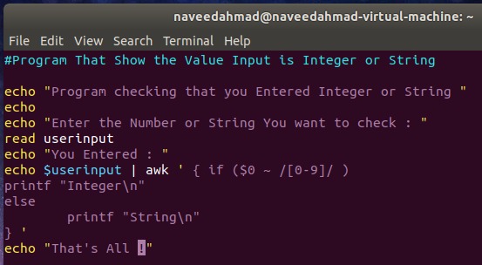

**Output :**

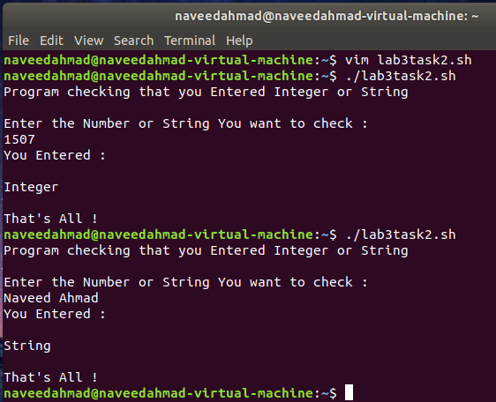

**Task : 03**

**Write a bash script that creates compressed backup (in zip format) of a directory.**

**The directory name or path is passed as a command line argument**

**Shell Script :**

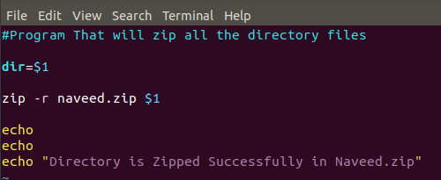

**Output :**

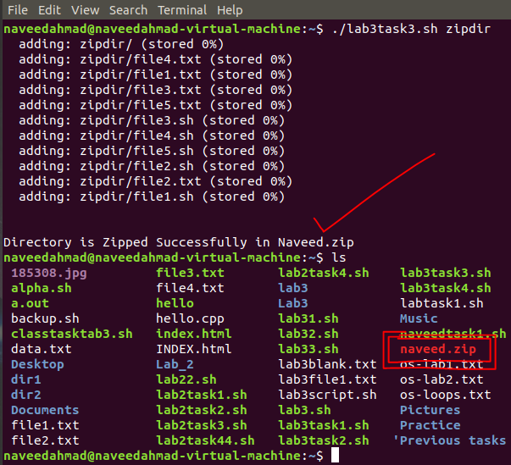

**Task : 04**

**Write a bash script that strips all the HTML tags from a specified HTML file.**

**Shell Script :**

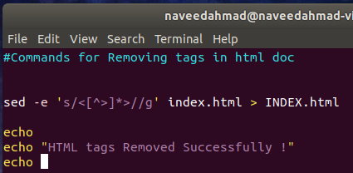

**Output A:**

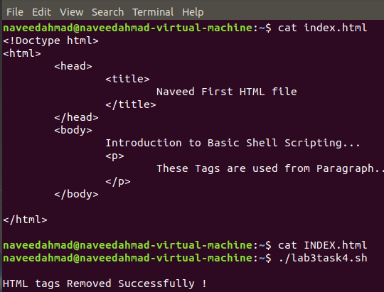

**Output B :**

